⚫ Installation of wsl in windows

1. First get to the windows store and install ubuntu18.0 LTS

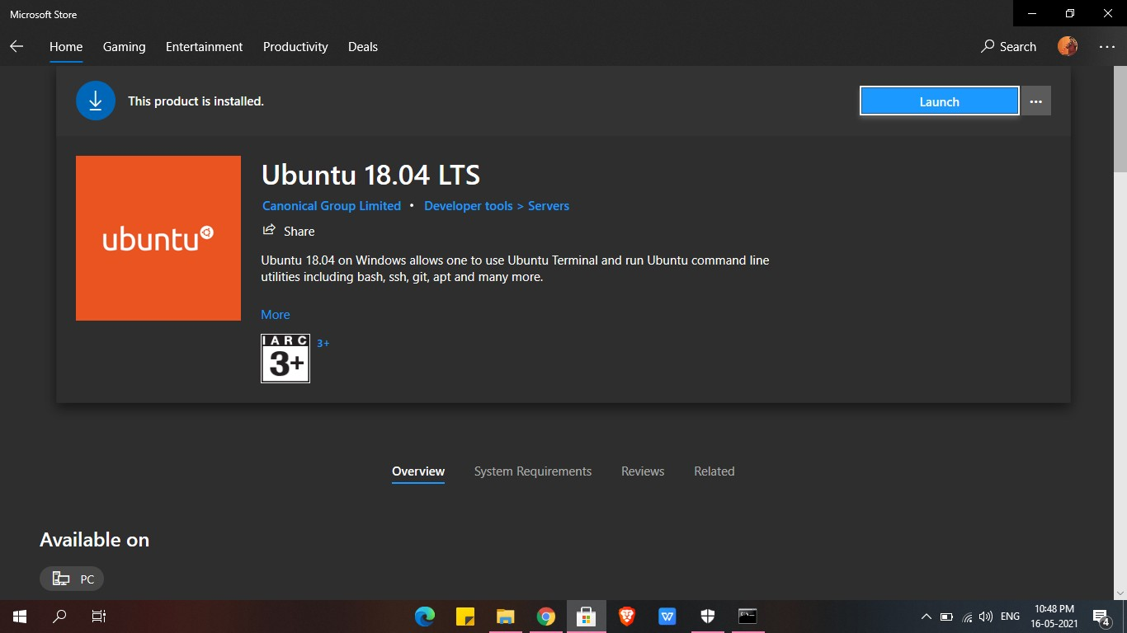

1. After installing it make sure u enable the wsl from turn on and off

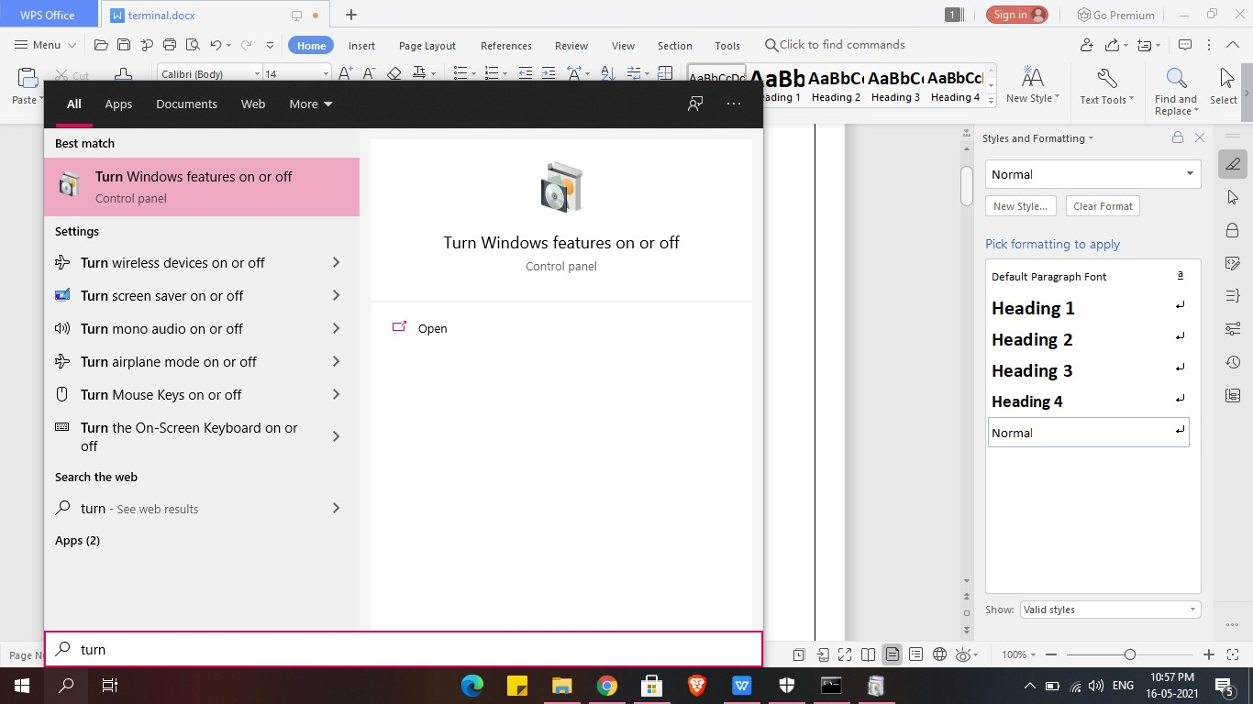

1. Enabling windows subsystem for linux

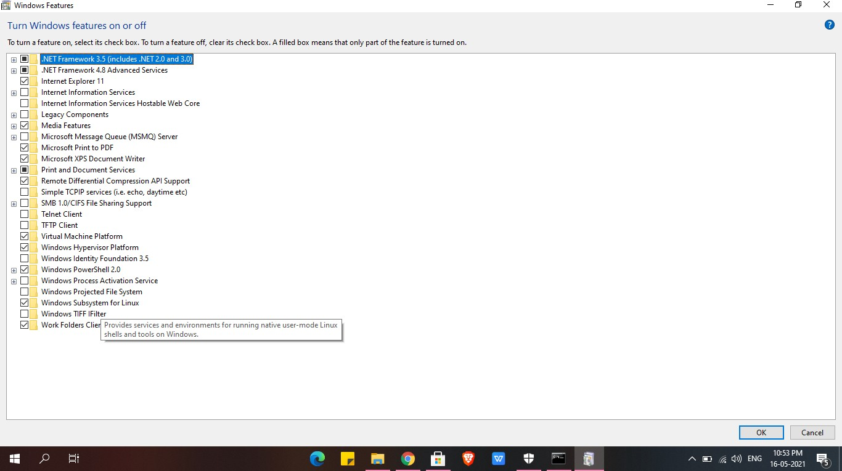

1. Now u can search ubuntu 18.0 LTS and use it.

